**TOPIC**

**INDIFFERENCE CURVE ANALYSIS**

**SUB TOPIC**

**1-INTRODUCTION**

**2-MEANING**

**3-ASSUMPTIONS**

**FOR B.A. (1)YEAR (ECONOMICS) ARTS**

**PREPARED BY**

**DR. SARASWATI**

**ASSISTANT PROFESSOR (ECONOMICS)**

**GOVT. DEGREE COLLEGE BHOJPUR, MORADABAD**

[drsaraswati081@gmail.com](mailto:drsaraswati081@gmail.com)

**E CONTENT (TEXT)**

Economists like Hicks, Allen, Samuelsons, Edgeworth etc have criticised the utility analysis on the following grounds:

•Utility is subjective. •Indivisible Goods. •Goods are not independent. •Marginal Utility of Money is not Constant. •Cardinal Measurement is not Possible. •Consumer is not so calculative. •Income Effect of Price change Ignored.

**INTRODUCTION OF INDIFFERENCE CURVE**

IC analysis is a modern method to analyse consumer’s behaviour. It is based on ordinal utility. There are two concepts of utility cardinal and ordinal. Cardinal is used to count or indicate how many while ordinal are words that represent rank and order in a set, scale of preference and the marginal rate of substitution. Ordinal utility refers to the level of satisfaction. The ordinal utility function means the utilities obtained from goods can be compared as being greater or less or equal through the level of satisfaction.

The scale of preference is the quantitativeexpression of consumer’s desire for goods. It shows the way in which an individual consumer decides to spend his money income on various commodities.

**Meaning of Indifference Curve**

• An IC is the locus of points – particular combinations which yield the same utility or level of satisfaction to the consumer, so that he is indifferent as to particular combination he consumes. In other words, IC analysis refers to the locus of points representing the various combinations of two goods which yield the same level of satisfaction to the consumer.

•According to Hicks: “It is the locus of the points representing parts of quantities between which the individual is indifferent and so it is termed as an indifferent curve.”

•According to Leftwhich : “A single indifference curve shows the indifferent combination of X and Ythat yield equal satisfaction to the consumer.”

**ASSUMPTIONS OF INDIFFERENCE CURVE ANALYSIS**

• Rationality.

• Ordinal Utility.

• Diminishing marginal rate of substitution.

• Based on comparison.

• Consistency.

We can explain the concept of IC approach with the help of table and Map

|  |  |  |  |
| --- | --- | --- | --- |
| COMBINATION | GOOD-X | GOOD-Y | MRSxy |
| A | 1 | 15 | ---- |
| B | 2 | 11 | 4:1 |
| C | 3 | 8 | 3:1 |
| D | 4 | 6 | 2:1 |
| E | 5 | 5 | 1:1 |

Here we are explaining MRS with the help of IC approach. The marginal rate of substitution of Y for X (MRSxy) is defined as the amount of Y the consumer is just willing to give up to get one additional units of X and maintain the same level of satisfaction. From the above table it is seen when the consumer moves from combination A to B, the consumer forgoes 4 units of Ygood for one unit gain of good X. Thus, marginal rate of substitution comes 4. In this way, when the consumer moves from B to C, the consumer forgoes 3 units of Y good for another unit of X good.

Thus the consumer has more and more unit of X good, the consumer is willing to a forgoes less units of Y good as of 2 and 1. In E combination, satisfaction of the consumer is 1:1. Thus utility gained = utility lost. It can also be expressed as MRSxy = y/x In short, as the stock of X increases the amount of Y in exchange will decrease. In this way, the marginal rate of substitution diminishes and the slope of indifference curve indicates the same.

**Diagrammatic Representation**

• In fig. given below at point A, consumer has 1 unit of X commodity and 15 units of Ycommodity. At point B, he has 2 units of X commodity and 4 units of Y commodity. According to the law of diminishing marginal utility, MU of additional units of X commodity is diminishing and marginal utility of Y starts increasing. Therefore, consumer will be willing to give up less and less of Y commodity for every additional units of X commodity. In other words, marginal rate of substitution of X commodity for Y commodity diminishes.

**Diagram of indifference curve**

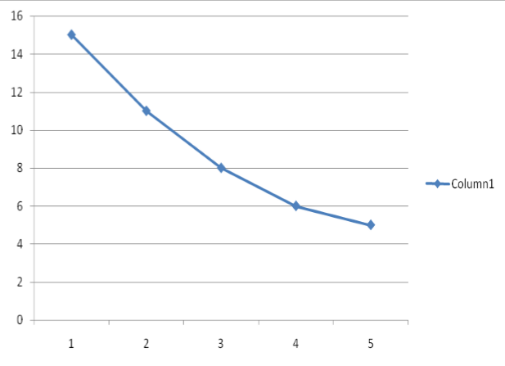

**PROPERTIES OF INDIFFERENCE CURVES:**

1. Indifference Curve Slope from Left Downward to Right. IC slope from left downward to right means when the amount of one commodity in the combination increases the amount of other commodity reduces. In the fig given below at point A, the consumer buys OX of commodity X and OY of commodity Y As he moves from A to B and further for attaining more of X commodity, he is ready to forgo lesser and lesser of commodity Y . It is only in this case that he can be indifferent between A and B because increase in commodity X leads to decrease in commodity Y .

**Convex and concave shape of indifference curve**

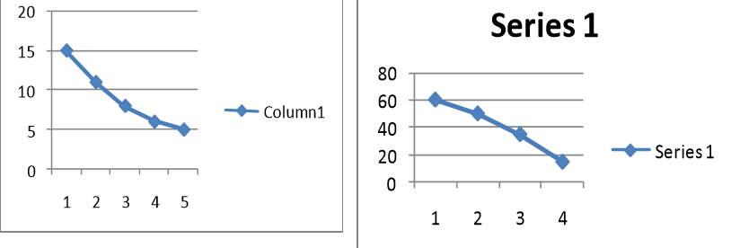

3. Indifference Curve will not Touch either X-axis or Yaxis. The IC will not touch either X-axis or Y- axis, as we have assumed that the individual is interested in different combinations of two commodities as seen in fig. below, If it touches either of the axis, it will mean that the consumer is interested in one commodity only. In the fig. IC touches X-axis at point A, he will be satisfied with OA units of X commodity and has no preference for Y commodity. Similarly, at point B, he will have OB units of Y commodity and none of X. This normally does not happen.

Indifference curve will not touch either x- axis and yaxis.

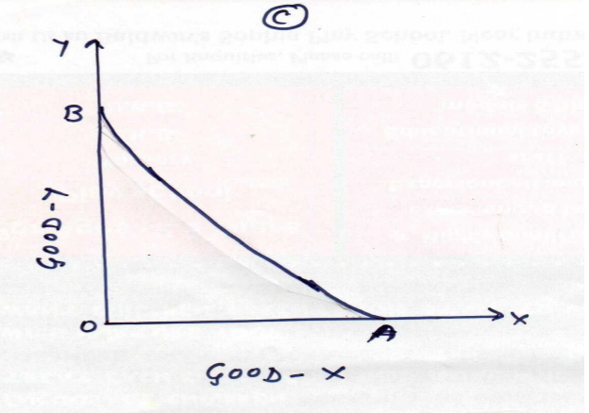

4. Indifference Curve neither Touches nor Intersects Each Other. Another property of IC is that IC can neither touch nor intersect each other so that only one IC can pass through any one point of the indifference map. In fig. given below two Indifferences curves IC1 and IC2 intersect each other at point P. On indifference curve IC2 combination M is preferable to combination N on indifference curve IC1. The reason for the preference is thus combination M lies on the higher indifference curve. Similarly, combination E is more preferred on IC1 to combination F on IC2.

Indifference Curve neither Touch nor Intersect Each Other.

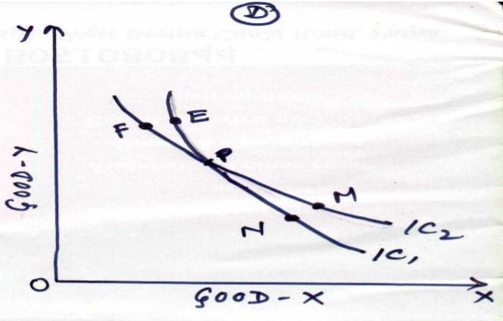

5. Higher Indifference Curve represents Higher Level of Satisfaction.An indifference curve which lies above and right to another indifference curve represent a higher level of satisfaction. In other words, the consumer will prefer the combination which lie on a higher indifference curve as compared to the combinations lying on a lower indifference curve.

**Higher Indifference Curve represents Higher Level of Satisfaction.**

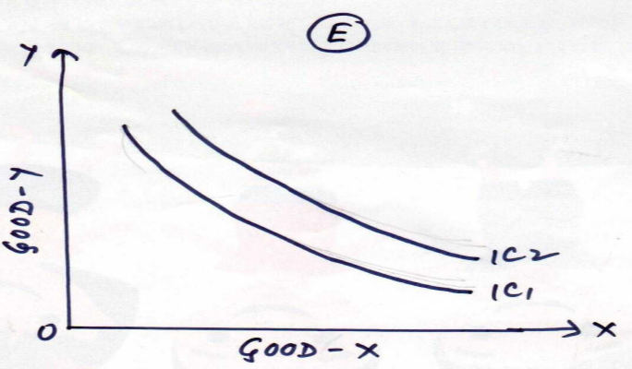

In this fig. IC2 is a higher indifference curve than the IC1, thus combination K has been taken on higher indifference curve and J on a lower indifference curve. Combination K will provide more satisfaction to the consumer instead of combination J which lies on a lower indifference curve. It is so because combination K represents more of two goods i.e., good-X and good-Y than the combination J. Therefore, the consumer must prefer K on IC2 instead of J on IC1.

6. Indifference Curves need not be Parallel to Each Other. This is because they are not based on the cardinal number system of measurability of utility. Secondly, the rate of substitution between two commodities need not be the same in all indifference schedules. From this it follows that IC may be drawn in any way parallel to each other or otherwise. The only condition is that the two IC should not touch or cut each other. This is explained in this diagram ,where there are three different indifference curves as IC1, IC2, IC3 which are not parallel to each other.

**KEY WORDS:**

**1-INDIFFERENCE CURVE**

**2-UTILITY**

**3-GOODS**

**4-CONSUMERS BEHAVIOUR**

**NOTES:**

**1-MISHRA PURI- MICROECONOMICS -I**

**2-RAMESH CHANDRA DAS- MICROECONOMICS THEORY AND PRACTICE**

**3-R.G. Lipsey- An introduction to positive economics**

**4-Samuelson Paul A -Economics**

**DECLERATION (I HAVE BY DECLARE THAT THE INFORMATION GIVING IN THIS FORM IS TRUE AN CORRECT TO THE BEST KNOWLEDGE AND BELIEF)**